PROJECT TITILE: SMART WATER FOUNTAINS

PHASE 5:PROJECT DOCUMENTATION AND SUBMISSION

Objectives :

* **Water Conservation:** IoT-enabled water fountains can monitor water levels and usage in real-time. By collecting data on water consumption, they can help conserve water resources by optimizing water flow and reducing waste.
* **Remote Monitoring:** IoT technology allows for remote monitoring and control of water fountains. Facility managers or maintenance teams can receive alerts and access data on fountain performance, helping them quickly address issues, perform maintenance, and reduce downtime.
* **Energy Efficiency:** Smart water fountains can be designed to be energy-efficient. IoT sensors can adjust pump and filtration systems based on demand and environmental conditions, thus reducing energy consumption and operating costs.
* **Water Quality Monitoring:** IoT sensors can continuously monitor water quality parameters such as pH levels, chlorine levels, and turbidity. When water quality deviates from desired levels, alerts can be generated to ensure that maintenance or water treatment measures are taken promptly.
* **User Interaction and Engagement:** IoT-enabled water fountains can provide a more engaging user experience. Features like touchless controls, smartphone apps, or interactive displays can enhance user satisfaction and encourage responsible water usage.
* **Data Analytics:** Collecting data from smart water fountains can provide valuable insights. Analytics can be used to understand usage patterns, peak hours, and areas where water conservation measures are most needed. This data can inform decision-making and help optimize water fountain placement.
* **Predictive Maintenance:** IoT sensors can predict maintenance needs based on usage patterns and the condition of fountain components. This proactive approach can extend the life of the equipment and reduce operational costs.
* **Cost Reduction:** Through improved water management and energy efficiency, smart water fountains can help reduce operational costs and promote sustainability.
* **Water Safety:** IoT technology can play a role in ensuring that the water from fountains is safe for consumption. Sensors can detect contaminants or irregularities and trigger warnings or shut off the water source to protect users.
* **Customization and Personalization:** Smart water fountains can be customized to cater to specific user preferences, such as water temperature control, flavor additives, or portion control.
* **Public Health:** In light of public health concerns, smart water fountains can implement features like touchless dispensing, UV-C sanitization, or periodic disinfection to enhance user safety and confidence.

## IOT SESOR DEPLOYMENT:

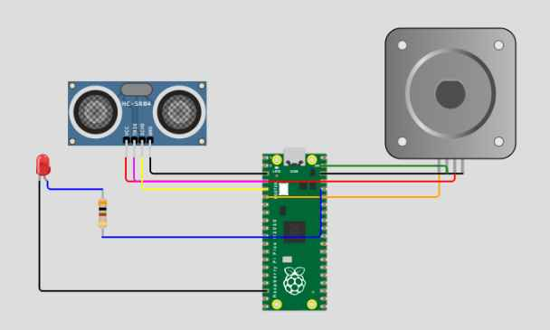

**Create by wowki**

## WOWKI DESCRIPTIOON:

import time # Import the time module for time delays

# Define GPIO pin numbers

TRIG_PIN = 2 # GPIO pin number for the ultrasonic sensor's trigger

ECHO_PIN = 3 # GPIO pin number for the ultrasonic sensor's echo

PUMP_PIN = 4 # GPIO pin number for the water pump

LED_PIN = 5 # GPIO pin number for the LED

# Initialize components (virtual components for Wokwi)

ultrasonic_sensor = Ultrasonic(TRIG_PIN, ECHO_PIN) # Create an ultrasonic sensor

pump = Motor(PUMP_PIN) # Create a water pump

led = LED(LED_PIN) # Create an LED

while True:

# Measure distance

distance = ultrasonic_sensor.distance_cm # Measure distance in centimeters

if distance > 200: # Water level is above 200 cm

# Make the LED blink

led.blink(on_time=0.5, off_time=0.5) # LED blinks with 0.5 seconds on and off time

pump.on() # Water pump is turned on

else:

# Water level is below 200 cm

# Turn off the LED and the pump

led.off()

pump.off()

# Introduce a small delay to control the loop rate

time.sleep(0.1) # Sleep for 0.1 seconds

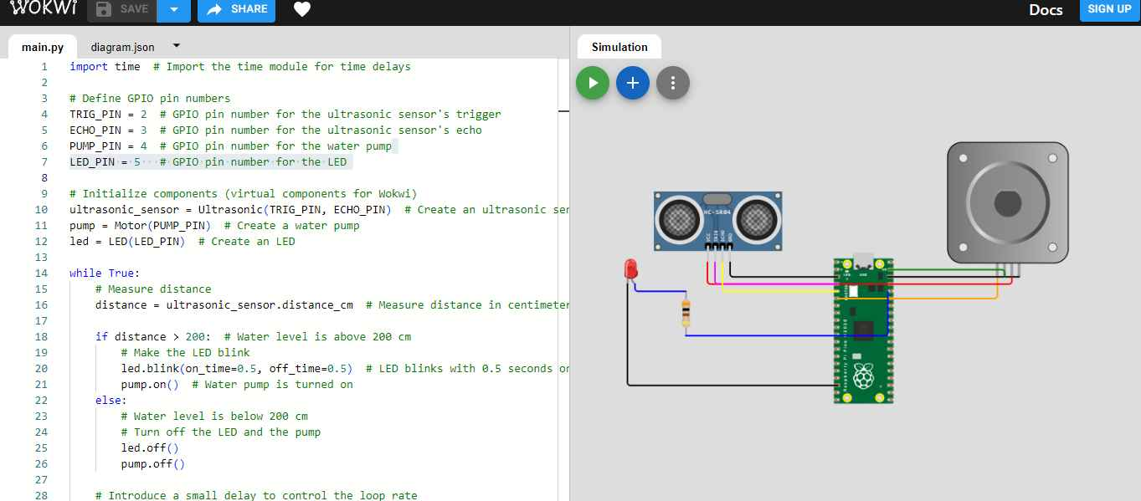

PLATFORM DEVELOPMENT:

## IoT Hardware Components:

## Sensors:

Depending on the specific requirements, you may use various sensors, such as flow sensors, water quality sensors, temperature sensors, pressure sensors, and proximity sensors.

## Microcontrollers:

Hardware like Arduino, Raspberry Pi, or specialized IoT development boards can be used to control and collect data from the sensors.

## Actuators:

Pumps, valves, and motors for water flow control.

Communication Modules: Wi-Fi, LoRa, Zigbee, or cellular modules for data transmission.

## Power Supply:

Ensure a reliable and efficient power source for the hardware components.

Software and IoT Platforms:

## IoT Development Platform:

Select an IoT development platform like AWS IoT, Azure IoT, or Google Cloud IoT, which offers services for device management, data processing, and security.

## Data Collection and Analysis:

Use software to collect, store, and analyze the data from sensors. This could be done using cloud services, databases, or custom software.

User Interface:

Develop a web or mobile application for users to monitor and control the water fountains remotely. Consider a responsive dashboard for real-time data visualization.

## Machine Learning and AI:

Implement machine learning algorithms for predictive maintenance, anomaly detection, and to optimize water usage based on historical data.

## Security:

Ensure data security and privacy by implementing proper authentication and authorization mechanisms.

Alerts and Notifications: Set up alerts and notifications for critical events, such as low water levels, equipment failures, or water quality issues.

## Control Logic:

Develop control algorithms to manage water flow, filtration, and purification processes.

## Cloud Services:

Utilize cloud services to store and process data. Services like AWS Lambda, Azure Functions, or Google Cloud Functions can help automate tasks based on specific events.

Database Systems:

Use databases (SQL or NoSQL) to store historical data, configuration settings, and user information.

## Mobile and Web Applications:

Develop user-friendly mobile and web applications for end-users to control and monitor the smart water fountains. These apps should provide real-time data visualization, control options, and alerts.

## APIs and Integration:

Create APIs to enable integration with other systems or third-party services, allowing for advanced features like weather-based water scheduling or integration with smart building management systems.

## Remote Access and Security:

Implement secure remote access to control the fountains, which can include multi-factor authentication and encrypted communication.

## Scalability:

Ensure that the platform is scalable to accommodate additional fountains or sensors as your network grows.

## Data Visualization and Analytics:

Implement data visualization tools and analytics to provide insights into water usage patterns, quality trends, and equipment performance.

## Maintenance and Support:

Consider providing remote troubleshooting and support features within your platform to address issues in real-time.

HTMAL

<!DOCTYPE html>

<html>

<head>

<title>Smart Water Fountain Control Panel</title>

<script>

// Simulated functions to control the water fountain (replace with actual IoT device communication)

function startFountain() {

alert("Fountain started!");

}

function stopFountain() {

alert("Fountain stopped!");

}

</script>

</head>

<body>

<h1>Smart Water Fountain Control Panel</h1>

<div>

<h2>Control</h2>

<button onclick="startFountain()">Start Fountain</button>

<button onclick="stopFountain()">Stop Fountain</button>

</div>

<div>

<h2>Status</h2>

<p>Current Status: <span id="status">Fountain is off</span></p>

</div>

</body>

</html>

Result analysis

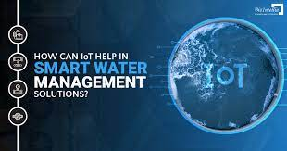

**EXPLANATION:**

Smart water fountains incorporating Internet of Things (IoT) technology have revolutionized the way we interact with and manage our water resources. These innovative fountains are equipped with a network of sensors and connected to the internet, allowing for real-time monitoring and control of water quality and usage. IoT-enabled water fountains can detect factors such as water flow, temperature, and chemical composition, ensuring the delivery of clean and safe drinking water. They also have the capability to adjust water flow based on demand, conserving water resources and reducing wastage. Furthermore, these fountains can provide data analytics and insights, which help water management authorities make informed decisions and improve overall water infrastructure efficiency. With the integration of IoT, smart water fountains are not just sources of refreshment but also crucial tools in promoting sustainable water management and ensuring public health.

**Conclution:**

In conclusion, smart water fountains leveraging the Internet of Things (IoT) represent a remarkable technological advancement that offers numerous benefits to both individuals and the environment. These innovative devices provide real-time data monitoring, remote control, and efficient resource management, ultimately promoting sustainability and convenience. By seamlessly integrating IoT technology with water fountains, we can reduce water wastage, enhance user experiences, and contribute to the conservation of our planet's most precious resource. As we continue to explore and implement smart solutions in our daily lives, the integration of IoT into water fountains is a compelling example of how technology can make our world not only smarter but also more responsible and eco-friendly.